Ex.No. 14: 5G Throughput vs SNR with Modulation Labels

AIM:
To simulate the performance of a 5G wireless communication system using MATLAB by analyzing the relationship between Throughput (Mbps), Signal-to-Noise Ratio (SNR) (dB), and different Modulation Schemes (QPSK, 16-QAM, 64-QAM, and 256-QAM).
Objective:
- To evaluate the Throughput (Mbps) of a 5G communication system under different Signal-to-Noise Ratio (SNR) conditions.\
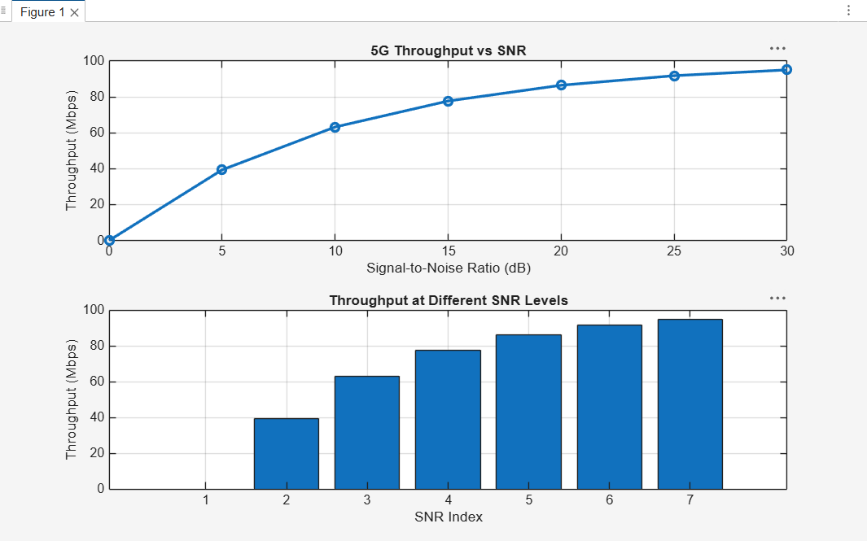
- To analyze the effect of Signal-to-Noise Ratio (SNR) (dB) on the performance and reliability of the 5G communication system.
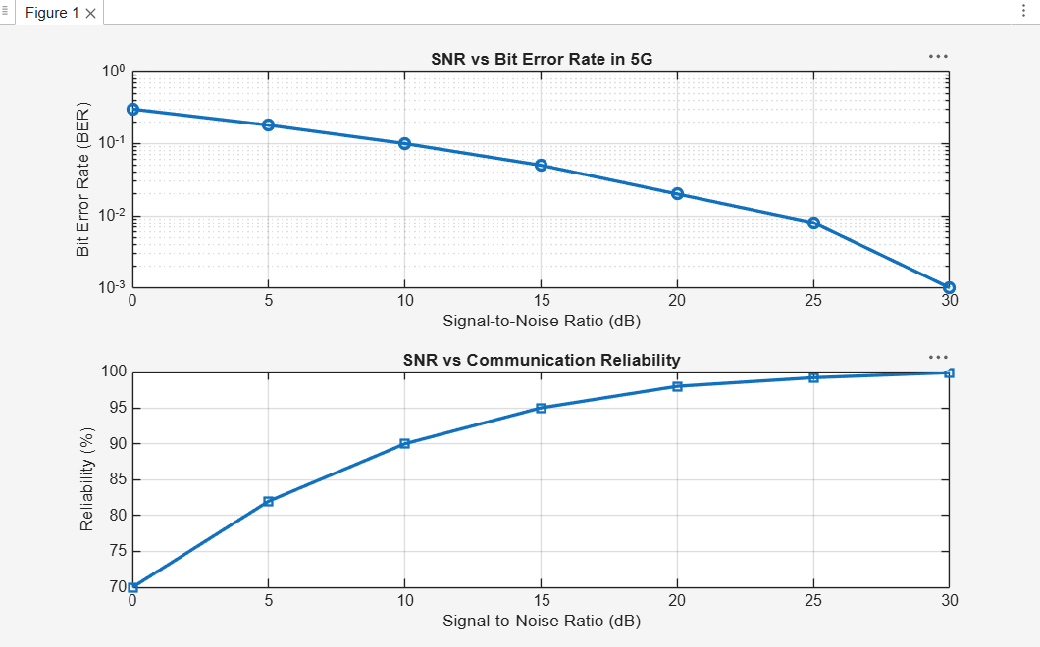
- To compare the performance of different Modulation Schemes (QPSK, 16-QAM, 64- QAM, and 256-QAM) and determine their suitability for varying SNR conditions.
